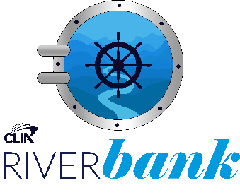

Apply for your share of funds from the CLIA RiverBank

Exclusively open to:
- Travel Agent Attendees of the CLIA RiverView Conference 2023 – Vienna
- RiverView Program members

Travel Agency
(Agency or
Franchise name)
CLIA Agency ID

Your name

Current status:
Please describe the current status of your river cruise business (in a couple of lines)

Overview:
Please tell us in a couple of sentences (max)
- what your plan is
- start and finish dates,
- what the money would be used for
Target market:
What will be your
- target reach (numbers of people who will see your activity)
- demographic
- location
Financials:
Funds requested
(max. £1,000)
Financials:
What funds will you/your agency be putting towards this activity
Support:
Will you need any support from river cruise operators to achieve your plan?
Target:
Please state the expected outcomes/your targets of the activity (bullet points would be perfect). Please note you will be asked to report on your successes against these targets
Timescale:
Following this activity, when will you be able to assess success
Additional supporting detail:

Additional application advice:
The more detail you provide with evidence that your plan is fully considered, and targets are achievable – the greater likelihood that our panel will be able to award funds for you.

We would also suggest that a request for smaller amounts of money is more likely to be approved and offered, as this allows us to share the funds across more of our members.

Applications will be assessed by Giles Hawke, Tom Dumbrell, Christian Kaatz and Angela Sloan; with funds being awarded to those with some of the best ideas. Our judges will meet in April, with winners announced in May.

Please note that all successful recipients of funds from the will be required to report on the success of the project, based on the timescale you state in your application. CLIA may wish to share any learnings or successes with their members via social media, Newsletters and online at cruising.org. All applicants must be happy for CLIA to report on their activity.

Email your application to riverview@cruising.org
Good luck!

